Vision Steering Wheel Switch - Contextual Message Center Buttons – CGEA1.3

Functional Description

Vision Steering Wheel switches are contextual message center buttons with two modes, Domain and Dialog. When in Domain mode, the message center buttons available are the Folder button (a.k.a. “i” or Info) and the Quick Action Menu (QAM) buttons that includes Phone, Media, Vehicle Settings, and Navigation. When in Dialog Mode, the message center buttons include Home, Up, Down, Back, and OK. Note that Up and Down will not be backlit.

The SCCM/SASM will debounce the switches aproximately 70ms before sending the HSCAN signals to the cluster. Also, the SCCM/SASM will handle a stuck button condition. Once a switch is pressed for 2 minutes, the SCCM/SASM will send as 'off' (not pressed). Finally, during Accessory and Delayed Accessory ignition states, when a button is pressed, the SCCM/SASM will wake the HSCAN bus and transmit the switch status, then allow bus sleep.

Interfaces

Interface Context Diagram (I/O Block Diagram)

Figure 1 Steering Wheel Switch Function Context Diagram

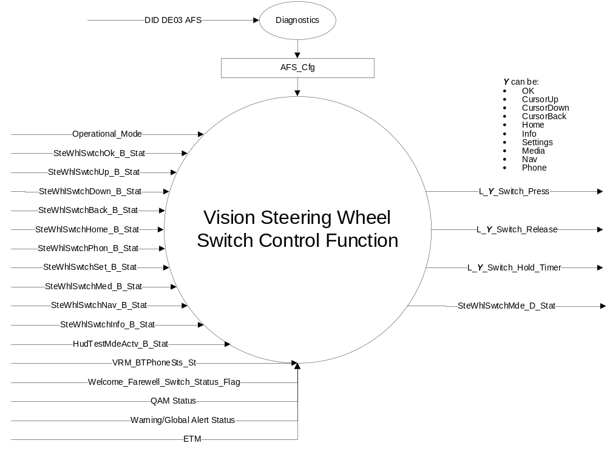

Inputs
Reference section 1.2.1 Interface diagram:
- Operational Mode
- Welcome_Farewell_Switch_Status_Flag (from Welcome-Goodbye Strategy - CGEA1.3)
- QAM Status (from Message Center Display with Vision Wheel Interface – CGEA 1.3)
- Warning/Global Alert Status (from Message Center Display with Vision Wheel Interface – CGEA 1.3)
- ETM (from Message Center Display with Vision Wheel Interface – CGEA 1.3)
- MUX messages on the CAN Network

- SteWhlSwtchY_B_Stat Signals
Signal Name | Size (bits) | Detail | Units | Res. | Offset | State Encoded | Min | Max
SteWhlSwtchHome_B_Stat | 1 |  | SED | 1 | 0 |  | 0(0x0) | 1(0x1)
 |  | Not Pressed |  |  |  | (0x0)
 |  | Pressed |  |  |  | (0x1)
SteWhlSwtchInfo_B_Stat | 1 |  | SED | 1 | 0 |  | 0(0x0) | 1(0x1)
 |  | Not Pressed |  |  |  | (0x0)
 |  | Pressed |  |  |  | (0x1)
SteWhlSwtchOk_B_Stat | 1 |  | SED | 1 | 0 |  | 0(0x0) | 1(0x1)
 |  | Not Pressed |  |  |  | (0x0)
 |  | Pressed |  |  |  | (0x1)
SteWhlSwtchUp_B_Stat | 1 |  | SED | 1 | 0 |  | 0 (0x0) | 1 (0x1)
 |  | Not Pressed |  |  |  | (0x0)
 |  | Pressed |  |  |  | (0x1)
SteWhlSwtchDown_B_Stat | 1 |  | SED | 1 | 0 |  | 0 (0x0) | 1 (0x1)
 |  | Not Pressed |  |  |  | (0x0)
 |  | Pressed |  |  |  | (0x1)
SteWhlSwtchBack_B_Stat | 1 |  | SED | 1 | 0 |  | 0 (0x0) | 1 (0x1)
 |  | Not Pressed |  |  |  | (0x0)
 |  | Pressed |  |  |  | (0x1)
SteWhlSwtchPhon_B_Stat | 1 |  | SED | 1 | 0 |  | 0(0x0) | 1(0x1)
 |  | Not Pressed |  |  |  | (0x0)
 |  | Pressed |  |  |  | (0x1)
SteWhlSwtchSet_B_Stat | 1 |  | SED | 1 | 0 |  | 0 (0x0) | 1 (0x1)
 |  | Not Pressed |  |  |  | (0x0)
 |  | Pressed |  |  |  | (0x1)
SteWhlSwtchMed_B_Stat | 1 |  | SED | 1 | 0 |  | 0 (0x0) | 1 (0x1)
 |  | Not Pressed |  |  |  | (0x0)
 |  | Pressed |  |  |  | (0x1)
SteWhlSwtchNav_B_Stat | 1 |  | SED | 1 | 0 |  | 0 (0x0) | 1 (0x1)
 |  | Not Pressed |  |  |  | (0x0)
 |  | Pressed |  |  |  | (0x1)

- HudTestMdeActv_B_Stat Signal
Signal Name | Size (bits) | Detail | Units | Res. | Offset | State Encoded | Min | Max
HudTestMdeActv_B_Stat | 1 |  | SED | 1 | 0 |  | 0 (0x0) | 1 (0x1)
 |  | Inactive |  |  |  | 0x0
 |  | Active |  |  |  | 0x1

- VRM_BTPhoneSts_St Signal
Signal Name | Size (bits) | Detail | Units | Res. | Offset | State Encoded | Min | Max
VRM_BTPhoneSts_St | 5 |  | Unitless | 1 | 0 |  | 0 (0x0) | 31 (0x1F)
 |  | Invalid |  |  |  | 0x0
 |  | Idle |  |  |  | 0x1
 |  | Dialing |  |  |  | 0x2
 |  | Connected |  |  |  | 0x3
 |  | CradlephNotReady |  |  |  | 0x4
 |  | NumUnobtainable |  |  |  | 0x5
 |  | IncomCall |  |  |  | 0x6
 |  | NoLinkToBt |  |  |  | 0x7
 |  | InitBtCon |  |  |  | 0x8
 |  | PhoneBusy |  |  |  | 0x9
 |  | PhoneVr |  |  |  | 0xA
 |  | NotSupported |  |  |  | 0xB
 |  | BtPhPriv |  |  |  | 0xC
 |  | ConfCall |  |  |  | 0xD
 |  | Conference_2ndIncCall |  |  |  | 0xE
 |  | Conference_OtherCallOnHold |  |  |  | 0xF
 |  | Connected_Call_on_hold |  |  |  | 0x10

Outputs

L_OK_Switch_Press
L_CursorUp_Switch_Press
L_CursorDown_Switch_Press
L_CursorBack_Switch_Press
L_Home_Switch_Press
L_Info_Switch_Press
L_Settings_Switch_Press
L_Media_Switch_Press
L_Nav_Switch_Press
L_Phone_Switch_Press
L_OK_Switch_Release
L_CursorUp_Switch_Release
L_CursorDown_Switch_Release
L_CursorBack_Switch_Release
L_ Home_Switch_Release
L_ Info_Switch_Release
L_Settings_Switch_Release
L_Media_Switch_Release
L_Nav_Switch_Release
L_ Phone_Switch_Release
L_OK_Switch_Hold_Timer
L_CursorUp_Switch_Hold_Timer
L_CursorDown_Switch_Hold_Timer
L_CursorBack_Switch_Hold_Timer
L_ Home_Switch_Hold_Timer
L_ Info_Switch_Hold_Timer
L_Settings_Switch_Hold_Timer
L_Media_Hold_Timer
L_Nav_Switch_Hold_Timer
L_ Phone_Switch_Hold_Timer

*Note: The “L_” prefix is part of a legacy naming convention used in other STSS’s. This prefix is maintained for consistency with other STSS’s and, as a result, may not represent the actual switch location on the steering wheel, whether it is positioned towards the left or right, as originally intended. The “L_” signal outputs are used only for cluster functions.

- MUX messages on the CAN Network

- SteWhlSwtchMde_D_Stat Signal
Signal Name | Size (bits) | Detail | Units | Res. | Offset | State Encoded | Min | Max
SteWhlSwtchMde_D_Stat | 2 |  | SED | 1 | 0 |  | 0 (0x0) | 3 (0x3)
 |  | Domain |  |  |  | (0x0)
 |  | Dialog |  |  |  | (0x1)
 |  | NotUsed_1 |  |  |  | (0x2)
 |  | NotUsed_2 |  |  |  | (0x3)

Function/Performance

Operational Modes
Table 1.2
Current Operating Mode | Functionality in Current Operating Mode
Sleep Mode | OFF
Limited Mode | OFF / Process Switch Input from HSCAN
Normal Mode | Process Switch Input from HSCAN
Crank Mode | Process Switch Input from HSCAN

Voltage Levels

Refer to the Cluster Features table located in the Operational Modes and Voltage Range Strategies Section in this SPSS.

Human-Machine Interface

Visual

Indicator Graphics / Display Format

Domain Mode
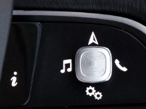

Dialog Mode
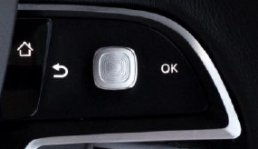

Indicator Color Coordinates

None

Indicator Characteristics

None

Audio

None

Switch Control Logic

Consumer access to message center displays shall be as specified in the Message Center – HMI Display STSS.

System Accuracy

Within 100 msec of receiving a message that results in a change of state the cluster will update the display to the proper state.

Operation: Performance and Functional

Subsystem Algorithm Flowchart / State Diagram

Figure 2 AFS Diagnostic Routine Diagram

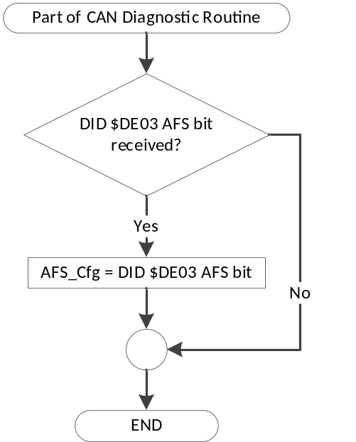

Figure 3 Switch_Mode State Diagram
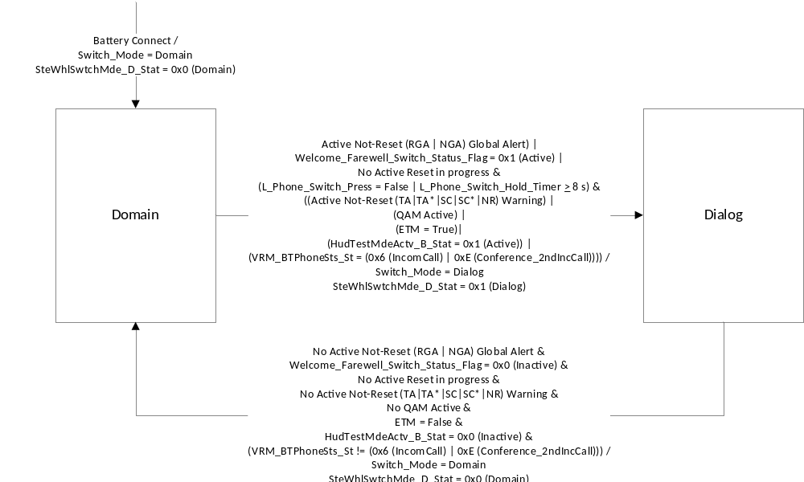
Figure 4 L_ Output Info, Settings, Media, Nav, and Phone Steering Wheel Switch State Diagram
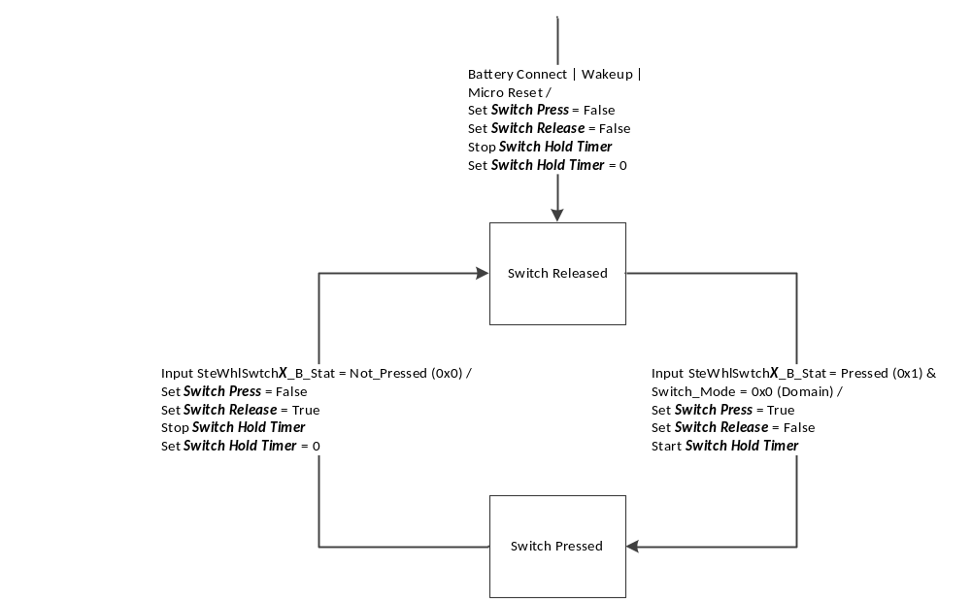
Figure 4 Notes:
1. 'Switch Press = True' and 'Switch Release = True' are events that can be cleared as follows:
- Other functions recognize and clear the event when used, or
- All unused switch events are cleared upon a transition to a new Message Center display state.

2. SteWhlSwtchX_B_Stat is used as a generic input where X can be Info, Phon, Med, or Nav, or Set giving the following possible inputs:

SteWhlSwtchInfo_B_Stat
SteWhlSwtchSet_B_Stat
SteWhlSwtchMed_B_Stat
SteWhlSwtchNav_B_Stat
SteWhlSwtchPhon_B_Stat

3. Switch inputs should never simultaneously be equal to 0x1 (Pressed). However, if this does occur, the instrument cluster will process these switch signal inputs in order of Start Bit location in the CAN message.

4. Switch Press, Switch Release, and Switch Hold Timer are generic outputs names. The word Switch will be replaced by the appropriate value of L_X_Switch_, where X can be Info, Settings, Media, Nav, or Phone.

L_Info_Switch_Press
L_Settings_Switch_Press
L_Media_Switch_Press
L_Nav_Switch_Press
L_Phone_Switch_Press
L_Info_Switch_Release
L_Settings_Switch_Release
L_Media_Switch_Release
L_Nav_Switch_Release
L_Phone_Switch_Release
L_Info_Switch_Hold_Timer
L_Settings_Switch_Hold_Timer
L_Media_Switch_Hold_Timer
L_Nav_Switch_Hold_Timer
L_Phone_Switch_Hold_Timer

Figure 5 L_ Output Home, Ok, Up, Down, and Back Steering Wheel Switch State Diagram
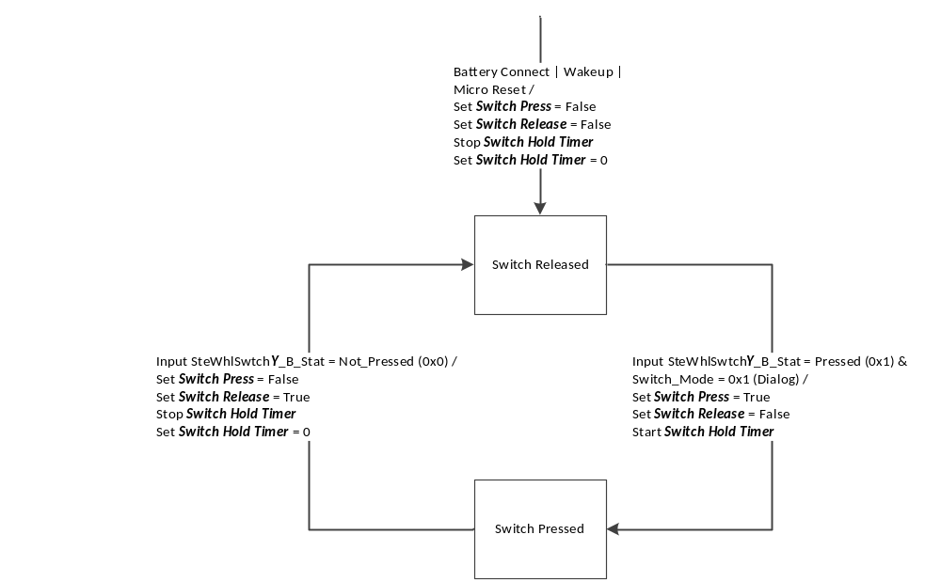
Figure 5 Notes:
1. 'Switch Press = True' and 'Switch Release = True' are events that can be cleared as follows:
- Other functions recognize and clear the event when used, or
- All unused switch events are cleared upon a transition to a new Message Center display state.

2. SteWhlSwtchY_B_Stat is used as a generic input where Y can be Home, Ok, Up, Down, or Back giving the following possible inputs:

SteWhlSwtchHome_B_Stat
SteWhlSwtchOk_B_Stat
SteWhlSwtchUp_B_Stat
SteWhlSwtchDown_B_Stat
SteWhlSwtchBack_B_Stat

3. Switch inputs should never simultaneously be equal to 0x1 (Pressed). However, if this does occur, the instrument cluster will process these switch signal inputs in order of Start Bit location in the CAN message.

4. Switch Press, Switch Release, and Switch Hold Timer are generic outputs names. The word Switch will be replaced by the appropriate value of L_Y_Switch_, where Y can be Home, OK, CursorUp, CursorDown, or CursorBack.

L_Home_Switch_Press
L_OK_Switch_Press
L_CursorUp_Switch_Press
L_CursorDown_Switch_Press
L_CursorBack_Switch_Press
L_Home_Switch_Release
L_OK_Switch_Release
L_CursorUp_Switch_Release
L_CursorDown_Switch_Release
L_CursorBack_Switch_Release
L_Home_Switch_Hold_Timer
L_OK_Switch_Hold_Timer
L_CursorUp_Switch_Hold_Timer
L_CursorDown_Switch_Hold_Timer
L_CursorBack_Switch_Hold_Timer

Operation Description (supports algorithm flowchart /state diagram)

None

Function Safety Classification (EMC)

Class B

Memory Storage

Parameter Name | Description | Value at  Battery Connect | Value at  Module Wake-up
Operational_Mode | 4 state indicator for cluster operational mode | Limited | Limited, Normal or Crank
SteWhlSwtchOk_B_Stat | HSCAN signal sent from SCCM | 0x0 | 0x0
SteWhlSwtchUp_B_Stat | HSCAN signal sent from SCCM | 0x0 | 0x0
SteWhlSwtchDown_B_Stat | HSCAN signal sent from SCCM | 0x0 | 0x0
SteWhlSwtchBack_B_Stat | HSCAN signal sent from SCCM | 0x0 | 0x0
SteWhlSwtchHome_B_Stat | HSCAN signal sent from SCCM | 0x0 | 0x0
SteWhlSwtchInfo_B_Stat | HSCAN signal sent from SCCM | 0x0 | 0x0
SteWhlSwtchSet_B_Stat | HSCAN signal sent from SCCM | 0x0 | 0x0
SteWhlSwtchMed_B_Stat | HSCAN signal sent from SCCM | 0x0 | 0x0
SteWhlSwtchNav_B_Stat | HSCAN signal sent from SCCM | 0x0 | 0x0
SteWhlSwtchPhon_B_Stat | HSCAN signal sent from SCCM | 0x0 | 0x0
SteWhlSwtchMde_D_Stat | HSCAN signal sent from IPC | 0x0 | Do Not Init
L_X_Switch_Press | Internal signal to cluster for switch press  X can be Info, Settings, Media, Navigation, or Phone. | 0x0 | 0x0
L_X_Switch_Release | Internal signal to cluster for switch release  X can be Info, Settings, Media, Navigation, or Phone. | 0x0 | 0x0
L_X_Switch_Hold_Timer | Internal signal to cluster for switch hold timer  X can be Info, Settings, Media, Navigation, or Phone. | 0x0 | 0x0
L_Y_Switch_Press | Internal signal to cluster for switch press  Y can be Home, OK, CursorUp, CursorDown, or CursorBack. | 0x0 | 0x0
L_Y_Switch_Release | Internal signal to cluster for switch release  Y can be Home, OK, CursorUp, CursorDown, or CursorBack. | 0x0 | 0x0
L_Y_Switch_Hold_Timer | Internal signal to cluster for switch hold timer  Y can be Home, OK, CursorUp, CursorDown, or CursorBack. | 0x0 | 0x0
Switch_Mode | 0x0 (Domain)  0x1 (Dialog) | 0x0 | Do Not Init
AFS_Cfg | State Indicator for feature presence controlled via CAN at EOL at VO plant. Defaulted to DISABLED at supplier manufacturing. | Use Stored Value | Use Stored Value
Welcome_Farewell_  Switch_Status_Flag | Status flag indicating Steering Wheel Switch is required for Welcome/Farewell  (From Welcome-Goodbye Strategy - CGEA1.3_v7.0+) | 0x0 (Inactive) | 0x0 (Inactive)
HudTestMdeActv_B_Stat | CAN signal indicating state of AHUD ETM | 0x0 (Inactive) | 0x0 (Inactive)
VRM_BTPhoneSts_St | CAN signal indication state of the phone | 0x0 (Invalid) | Do not init
ETM | Internal variable indicating if the instrument cluster is in Engineering Test Mode (ETM) | False | False

Prove-Out

None

Error Handling

Missing Message Strategy

The signals will be declared missing as per the Diagnostics section of this SPSS.

DTCs states and history will be determined as per the Diagnostics section of this SPSS.

If missing message is declared then log the DTC 12600 if AFS_Cfg = 0x1 (enabled), else log DTC C21200.

Diagnostics

Self Test

None

Engineering Test Mode

Reference section “Dealer / Engineering Test Mode (ETM)”

Part II Performance

DID $DExx
Block  Num | Block Description | Size (bits) | Byte(s) | Bit(s) | State: Description | "0" | "1" | Default | Comments/  Information
PACKETED BLOCKS
$03 | Option Content (B&A) | 1 | * | * | Active Front Steering | Disabled | Enabled | Disabled | Disabled means the feature is not present in the vehicle.
 | *Byte and bit location to be identified in Part II Specification for this cluster.

Supported Diagnostic Trouble Codes (DTCs)
DTC | Description | When Logged
C21200 | Lost Communication with Steering Column Control Module | Input signals missing for more than 5 seconds
C12600 | Lost Communication With Steering Angle Sensor Module | Input signals missing for more than 5 seconds

Reference Specification

- Steering Column Switch Module Functional Specification CGEA 1.3 or later
- Message Center – HMI Display STSS.

Revision History
SPSS Module Revision History

Revision Level | Name | Change Description | Date
1.0 | J. Gregoire | Initial release.  Steering Wheel Switch - 4-Way with Rocker Hotkeys - CGEA1.3_v3.0 was used as a foundation specification to write this STSS. | 9/12/2017
1.1 | J. Gregoire | Feature Owner: Thomas Metcalf  DI Change Control October 19, 2017 – Set a DTC against the SASM, if equipped (Lead Program U611)  Page 1 Figure 1 – Add AFS_Cfg.  Page 5 Figure 2 – New for AFS_Cfg.  Page 8 Section 1.3.5.4 – Add AFS_Cfg.  Page 9 Section 1.4.1 – Add AFS_Cfg and DTC C12600.  Page 9 Section 1.5.3 – Add AFS_Cfg and DTC C12600.  Supplier Q&A  Page 8 Section 1.3.5.4 – Correct SteWhlSwtchMde_D_Stat and Switch_Mode. | 11/1/2017
1.2 | J. Gregoire | Supplier Q&A 944448 – Page 43 of Message Center Display with Vision Wheel Interface – CGEA 1.3_v1.0 STSS shows behavior to enter ETM mode and says Phone QAM button should be held for 5 Seconds to enter ETM mode instead of OK button since OK is not available during 'Domain' mode. However, this will be an issue if any Warning is displayed once Ignition transitions to RUN mode (after bulb proveout). If any warning is activated immediately after bulb proveout, we will enter 'Dialog' mode and PHONE button will no longer be available and it will be impossible to enter ETM. Also, this ETM flow shows transition if "L_Phone_Switch_Hold_Timer > 8 s" from ET100 to ETM = FALSE. This case is impossible since when ETM_Mode becomes TRUE, we will enter Dialog mode and Phone button will no longer be available.  Page 5 Figure 3 – Add “(L_Phone_Switch_Press = False | L_Phone_Switch_Hold_Timer > 8 s)” as a necessary condition in the path from Domain to Dialog. | 2/23/2018
1.3 | J. Gregoire | Changes highlighted in Orange.  Peer review: Scott Watkins  Missed requirement – Switch Mode should be in Dialog Mode for Welcome/Farewell when scrolling between screens is required, ex. EV Farewell.  Page 6 Figure 3 – Add Welcome_Farewell_Switch_Status_Flag condition.  Page 9 Section 1.3.5.4 – Add Welcome_Farewell_Switch_Status_Flag  Spec clean-up.  Page 1 Figure 1 – Add missing inputs  Page 2 Section 1.2.2 – Add missing inputs  Page 3 Table 1.1 – New table for CAN signal  Page 3 Table 1.2 – New table for CAN signal  Page 9 Section 1.3.5.4 – Add HudTestMdeActv_B_Stat, VRM_BTPhoneSts_St, ETM. | 06/13/2018

